Use Case Realisation Report (Analysis) - Manage Project
FOR
Volunteer Management System
(VMS)

CLIENT
PROJECT | Volunteer Management System (VMS)Volunteer Management System
TITLE | Use Case Realisation Report (Analysis) - Manage Project
VERSION | 0.3a0.2a
DATE | 13-Aug-2011
 | ORIGINATOR
 | Name / Signature | Team 8S
 | APPROVAL
 | Name / Signature | Phung Kim Cuong, Dio
Institute of Systems Science |  | Document Reference
25 Heng Mui Keng Terrence  Singapore 119615 |  | VMS/T-1.4.1/1

 | Acceptance
 | Customer Signature |  | Customer Signature
 | Name & Designation |  | Name & Designation
 | Date & Company Stamp |  | Date & Company Stamp

Revision History

Date | Version | Description | Author
12-Jun-2011 | 0.1a | Creation | Team 8S
12-Aug-2011 | 0.2a | Updates | Team 8S
12-Aug-2011 | 0.3a | Updates | Team 8S

Table of Contents

1. Brief Description 3
2. Flow of Events 3
2.1 Standard Flow 3
2.1.1 List Project 3
2.1.2 Search Project 3
2.1.3 View Project 4
2.1.4 Create Project 4
2.1.5 Update Project 5
2.2 Exceptions 5
3. Interaction Diagrams 6
3.1 Collaboration Diagram for List Project 6
3.2 Collaboration Diagram for Search Project 7
3.3 Collaboration Diagram for View Project 8
3.4 Collaboration Diagram for Create Project 8
3.5 Collaboration Diagram for Update Project 9
4. Participating Objects 9
4.1 Staff 9
4.2 Project Manager 9
4.3 Date 9
4.4 Project 9
4.5 ProjectListingScreen 10
4.6 CreateProjectScreen 10
4.7 UpdateProjectScreen 10
4.8 ViewProjectScreen 10
4.9 HomeScreen 10
4.10 MainController 10
4.11 ProjectController 10
5. Class Diagrams 11
6. Derived Requirements 11
ANNEX D Amendment History 12

Use Case Realisation Report (Analysis) - Manage Project

Brief Description
The use case enables the Project Manager to perform management of project sites that he is in-charge of.

Flow of Events
The standard flow of events for this use case and any exceptions are described in the following subsections. See section 3 for an overview of the participating Actors and Domain Objects.

Standard Flow
Precondition: User has logged in the system.
This use case provides the user interface related functionality that will be provided to the Project Manager for interaction with regards to project management, as follows:

List Project
- The use case starts when the User selects the project option from the HomeScreen. The HomeScreen.getProjectListMenu() operation is triggered.
- The getProjectList() operation triggers the MainController.getProjectList() which delegates to the ProjectController.getProjectList() operation.
- Using the userID, the ProjectController.getProjectList() operation triggers Project.getProject() operation to retrieve the project records. The ProjectController.getProjectList() operation triggers also triggers the Staff.getStaff() operation to retrieve the user record.
- The ProjectController triggers the ProjectListingScreen.show() operation to display the list of projects by triggering the Project.getAttribute() operation and Staff.getAttribute() operation.
- The use case terminates.

Search Project
- The use case starts when the User selects the search project option from the ProjectListingScreen. The ProjectListingScreen.getViewSearch() operation is triggered.
- The ProjectController triggers the SearchProjectScreen.show() operation to display the SearchProjectScreen.
- The User enters a number of criteria for the project into the SearchProjectScreen and selects the Search button. The SearchProjectScreen.search() operation is triggered which in terms triggers the ProjectController.getProjectBySearchCriteria() using the search criteria of project name, country, location, start date, project status and project manager to perform the search.
- The ProjectController triggers the Project.getProject() operation and Staff.getStaff() operation to retrieve the information of the project.
- The ProjectController triggers the ProjectListingScreen.show() operation to display the list of projects by triggering the Project.getAttribute() operation and Staff.getAttribute() operation.
- The use case terminates.

View Project
- The use case starts when the Project Manager selects a record to view from the ProjectListingScreen. The ProjectListingScreen.getViewProject() operation is triggered.
- The ProjectController.getViewProject() operation triggers Staff.getStaff() operation to retrieve the user details and the Project.getProject() operation is triggered to retrieve the project details using userID to retirieve projects that only the logon user has access to.
- The ProjectController triggers the ViewProjectScreen.show() operation to display the ViewProjectScreen by triggering the Staff.getAttribute() operation to retrieve the staff detail and the Project.getAttribute() operation to display the details.

Create Project
- The use case starts when the Project Manager selects the create project option from the ProjectListingScreen. The ProjectListingScreen.getViewCreate() operation is triggered.
- Using the userID, the ProjectController.getViewCreate() operation triggers Staff.getStaff() operation to retrieve the user record to default the Project Manager field.
- The ProjectController triggers the CreateProjectScreen.show() operation to display the CreateProjectScreen by triggering the Staff.getAttribute() operation to retrieve the staff detail for the Project Manager.
- The Project Manager enters the project details of the new project into the text fields of CreateProjectScreen.
- When the Project Manager selects the Create button in the form, the CreateProjectScreen.validate() operation performs form validation based on the input fields.
- Upon successful validation, CreateProjectScreen.createProject() operation triggers the ProjectController.createProject() operation and provides the Project object to create a project. The createProject() operation assigns a new project ID by using the operation Project.getNextProjectID() operation.
- The ProjectController.createProject() operation sets the date of created date of the project which the date is retrieved via the Date.getDate().
- The ProjectController triggers Project.createProject() operation to create the new Project object details including name, description, country, location, startDate and staff detail. The system displays an informational message for successfully updated message in the ProjectListingScreen by triggering the ProjectListingScreen.showMessage() operation.
- The use case terminates.

Update Project
- The use case starts when the Project Manager selects the update project option from the ProjectListingScreen. The ProjectListingScreen.getViewUpdate() operation is triggered.
- The ProjectController.getViewUpdate() operation triggers Staff.getStaff() operation to retrieve the user details and the Project.getProject() operation is triggered to retrieve the project details.
- The ProjectController triggers the UpdateProjectScreen.show() operation to display the UpdateProjectScreen by triggering the Staff.getAttribute() operation to retrieve the staff detail and the Project.getAttribute() operation to display the details.
- The Project Manager updates the project details of the project into the text fields of UpdateProjectScreen.
- When the Project Manager selects the Update button in the form, the UpdateProjectScreen.validate() operation performs form validation based on the input fields.
- Upon successful validation, UpdateProjectScreen.updateProject() operation triggers the ProjectController.updateProject() operation and provides the Project object to update the project.
- The ProjectController triggers Project.updateProject() operation to update the new Project object details including name, description, country, location, startDate, endDate, and status. The system displays an informational message for successfully updated message in the ProjectListingScreen by triggering the ProjectListingScreen.showMessage() operation.
- The use case terminates.

Exceptions
The following exceptions were identified:
- Validation fails. If the CreateProjectScreen.validate() operation fails, the project creation fails. An error message is displayed in the CreateProjectScreen by triggering the operation CreateProjectScreen.showMessage().
- Validation fails. If the UpdateProjectScreen.validate() operation fails, the project creation fails. An error message is displayed in the UpdateProjectScreen by triggering the operation UpdateProjectScreen.showMessage().

Interaction Diagrams

Collaboration Diagram for List Project
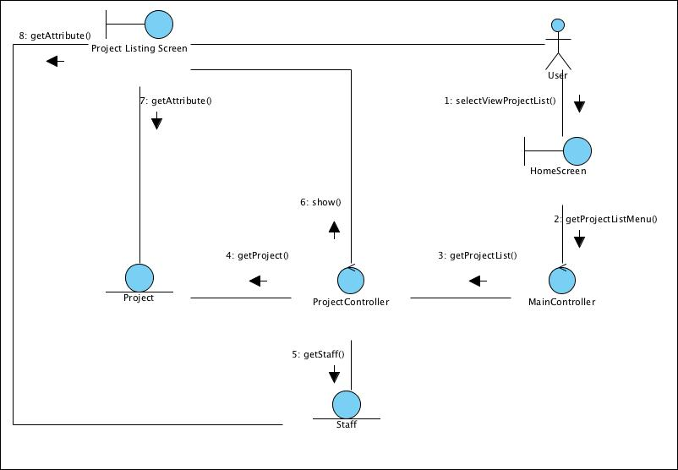
Figure 1 – Collaboration Diagram for List Project

Collaboration Diagram for Search Project
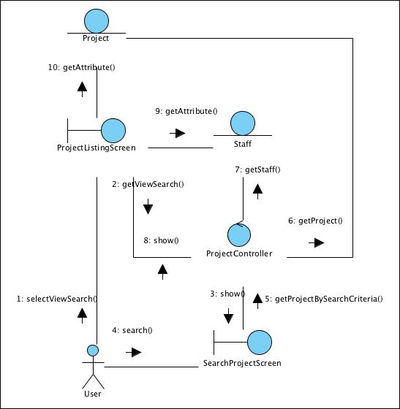
Figure 2 – Collaboration Diagram for Search Project

Collaboration Diagram for View Project
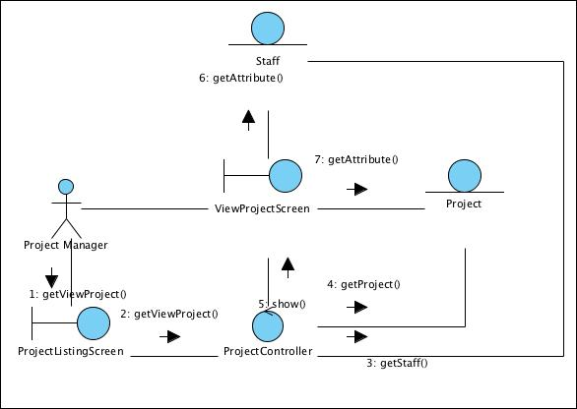
Figure 3 – Collaboration Diagram for View Project

Collaboration Diagram for Create Project
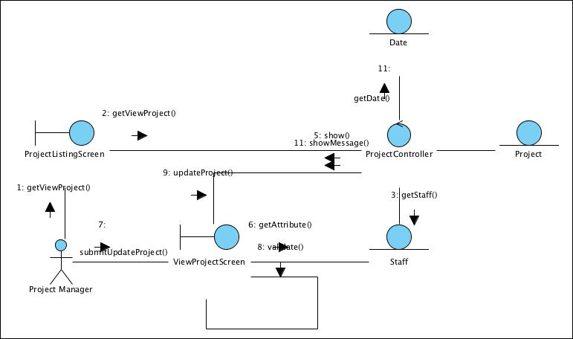
Figure 4 – Collaboration Diagram for View Project

Collaboration Diagram for Update Project
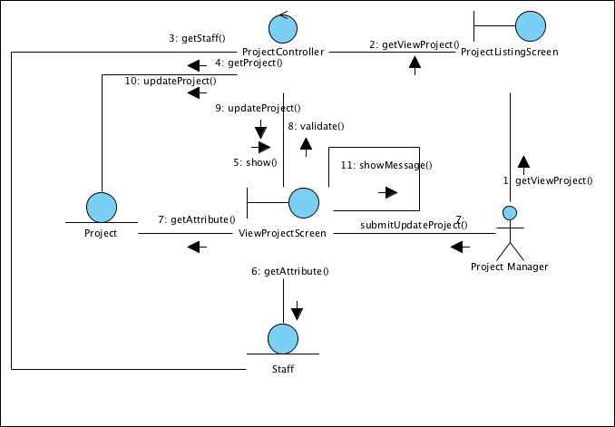
Figure 5 – Collaboration Diagram for View Project

Participating Objects

Staff
This entity object stores the details concerning a staff of the volunteer organisation. The primary attribute that it holds is the userID.

Project Manager
This is a Staff object type with a project manager role as an attribute.

Date
This entity object stores the current date.

Project
This entity object stores the details concerning a project of the volunteer organisation. The primary attribute that it holds is the projectID.

ProjectListingScreen
This boundary object is used for collection of project listing details. User actor uses this object.

CreateProjectScreen
This boundary object is used for collection of project details, which a new project record is to be created. The Project Manager actor uses this object.

UpdateProjectScreen
This boundary object is used for collection of project details, which a project record is to be updated. The Project Manager actor uses this object.

ViewProjectScreen
This boundary object is used for collection of project details, which a project record is to be viewed. The User actor uses this object.

HomeScreen
This boundary object is used for redirecting and displaying of home screen details and menu. All the user actors use this object.

MainController
This control object co-ordinates the menu selection and dispatches of requests of the volunteer management system. It delegates the user requests to the specific use case control objects for carrying out the use cases.

ProjectController
This control object co-ordinates the creation, update, viewing and searching project record in the volunteer management system. It receives requests from the boundary objects allocated for the specific purposes, along with all the necessary details required for the execution of these requests.

Class Diagrams
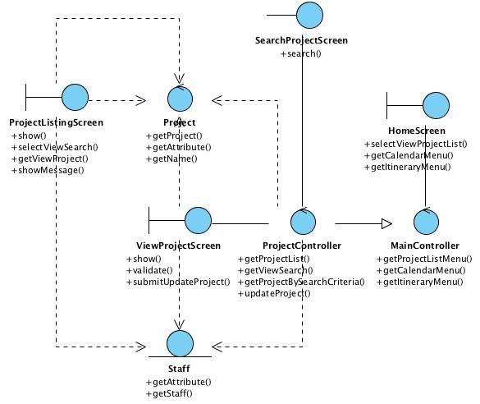
Figure 6 – Class Diagram

Derived Requirements
The Staff office PC (client system), keyboard and mouse will be used to process the project details and view all the system responses.

ANNEX D Amendment History

This is a record of all amendments made to the Document.
Version | Chapter / Section | Page No | Notes of Amendments or Changes

